**Pizza sales sql Queries**

**KPI’s REQUIREMENT  
1. Total revenue**select sum(total_price) as Total_Revenue from pizza_sales  
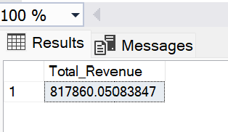

**2.Avg order value**SELECT * FROM pizza_sales

SELECT SUM(total_price) / COUNT(DISTINCT order_id) as Avg_Order_Value from pizza_sales  
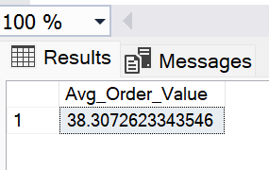

**3.** **Total pizzas sold**

SELECT * FROM pizza_sales

SELECT SUM(quantity) AS Total_pizza_sold from pizza_sales

**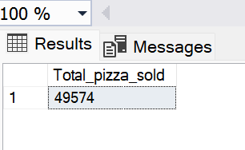  
 4.Total orders**

SELECT * FROM pizza_sales

SELECT COUNT(DISTINCT order_id) AS Total_Orders from pizza_sales

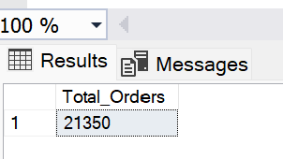

**5.Average pizzas per order**

SELECT * FROM pizza_sales

SELECT CAST (CAST (SUM(quantity) AS DECIMAL (10,2))/

CAST (COUNT(DISTINCT order_id ) AS DECIMAL (10,2)) AS DECIMAL(10,2)) AS avg_pizzas_per_order FROM pizza_sales

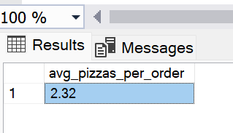

**CHARTS REQUIREMENT**

**1.Daily trend for total orders**

SELECT * FROM pizza_sales

SELECT DATENAME(DW,order_date) AS order_day, COUNT(DISTINCT order_id) AS Total_orders from pizza_sales

GROUP BY DATENAME(DW,order_date)

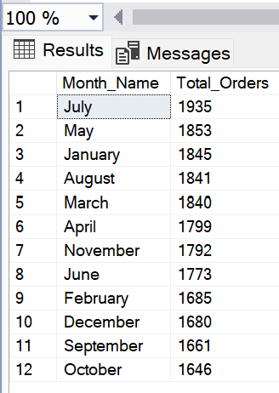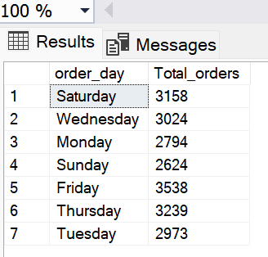

**2.Hourly trend by total orders**

SELECT * FROM pizza_sales

SELECT DATENAME(MONTH,order_date) AS Month_Name, COUNT(DISTINCT order_id) AS Total_Orders FROM pizza_sales

GROUP BY DATENAME(MONTH,order_date)

ORDER BY Total_Orders DESC

**3.percentage of sales by pizza category**

SELECT pizza_category,sum(total_price) as Total_Sales,SUM(total_price)* 100/

(SELECT sum(total_price) from pizza_sales WHERE MONTH(order_date) = 1 ) as PCT from pizza_sales

WHERE MONTH(order_date) = 1

GROUP BY pizza_category

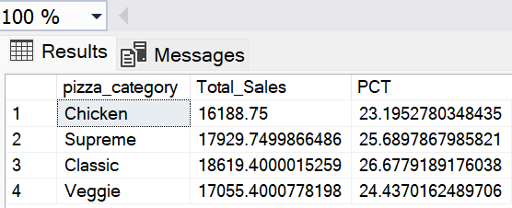

**4.percentage of sales by pizza size** SELECT pizza_size, CAST(sum(total_price) AS DECIMAL (10,2)) as Total_Sales, CAST(SUM(total_price)* 100/

(SELECT sum(total_price) from pizza_sales WHERE DATEPART(quarter,order_date)=1)as decimal(10,2)) as PCT from pizza_sales

WHERE DATEPART(quarter,order_date)=1

GROUP BY pizza_size

order by PCT desc

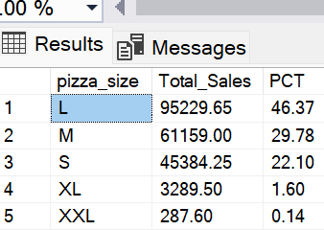

**5.Top 5 Best Seller by Revenue , Total Quantity and Total orders**

SELECT * FROM pizza_sales

SELECT TOP 5 pizza_name,sum(total_price) AS Total_Revenue FROM pizza_sales

GROUP BY pizza_name

ORDER BY Total_Revenue DESC

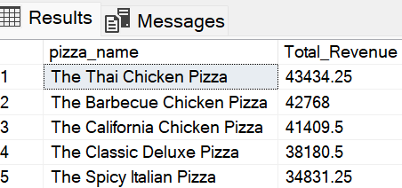

**6.BOTTOM 5 Pizzas by Revenue**

SELECT * FROM pizza_sales

SELECT TOP 5 pizza_name,sum(total_price) AS Total_Revenue FROM pizza_sales

GROUP BY pizza_name

ORDER BY Total_Revenue ASC

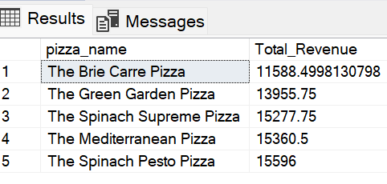

**7.TOP 5 PIZZAS BY QUANTITY**

SELECT * FROM pizza_sales

SELECT TOP 5 pizza_name,sum(quantity) AS Total_Quantity FROM pizza_sales

GROUP BY pizza_name

ORDER BY Total_quantity DESC

